**1.** What do we want to predict from the dataset?

* price
* colour
* make

**2.** Select the libraries you will use for this course?

* matplotlib
* pandas
* scikit-learn
* TensorFlow

**3.** We have the list **headers_list:**

1. headers_list=['A','B','C']

We also have the dataframe **df** that contains three columns, what is the correct syntax to replace the headers of the dataframe df with values in the list **headers_list?**

* **df.columns =** **headers_list**
* **df.head()**
* **df.tail()**

**4.** Consider the segment of the following dataframe:

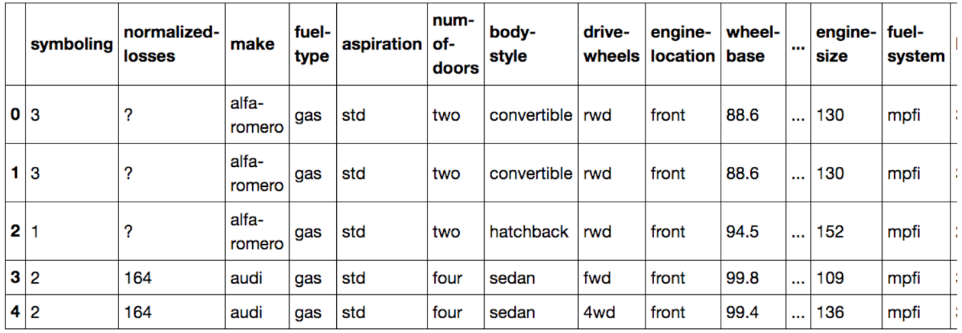

What is the type of the column **make**?

* float64
* int64
* object

**5.** If you use the method **describe()** without changing any of the arguments you will get a statistical summary of all the columns of type object?

* false
* true